Supervised learning
- Having labelled data : inputs (features X) and outputs (target Y)
- The algorithm learns from training data to predict outcomes for new data
- Example
  - Regression
    - Predicting house prices
      - Input – no.of bedrooms, size of house, location
      - Output – house price
  - Classification
    - Spam detection of emails
      - Inputs – words in the email
      - Output – spam or not spam

Unsupervised learning
What if we don’t have labels? No target variable
Algorithm job is not to predict, but to discover patterns in the data
Clustering
Ex
Lets say you visited a place
- One group is chatting about football
- Another group is discussing movies
- Third group talking about business
This is nothing but clustering – people with similarities naturally form groups, without any labeling them first.

Clustering – grouping similar data points together
Ex
Bank wants to know if their customers form natural subgroups
- Cluster-1 : young professional (20 – 30, high online transations)
- Cluster-2 : families (30 – 50, home loands, school expenses)
- Cluster-3: retired seniors (60+ fixed deposits)

Types of clustering algorithms
- K-means clustering
  - Pre-define how many clusters (K) you want
  - Algorithm assigns each data point to one of these clusters by finding the closest center
  - Ex – divide customers into 3 groups for targeted marketing campaigns
- Hierarchical clustering
  - Builds a “tree” of clusters
  - Starts with each data point as its own cluster merges them step by step
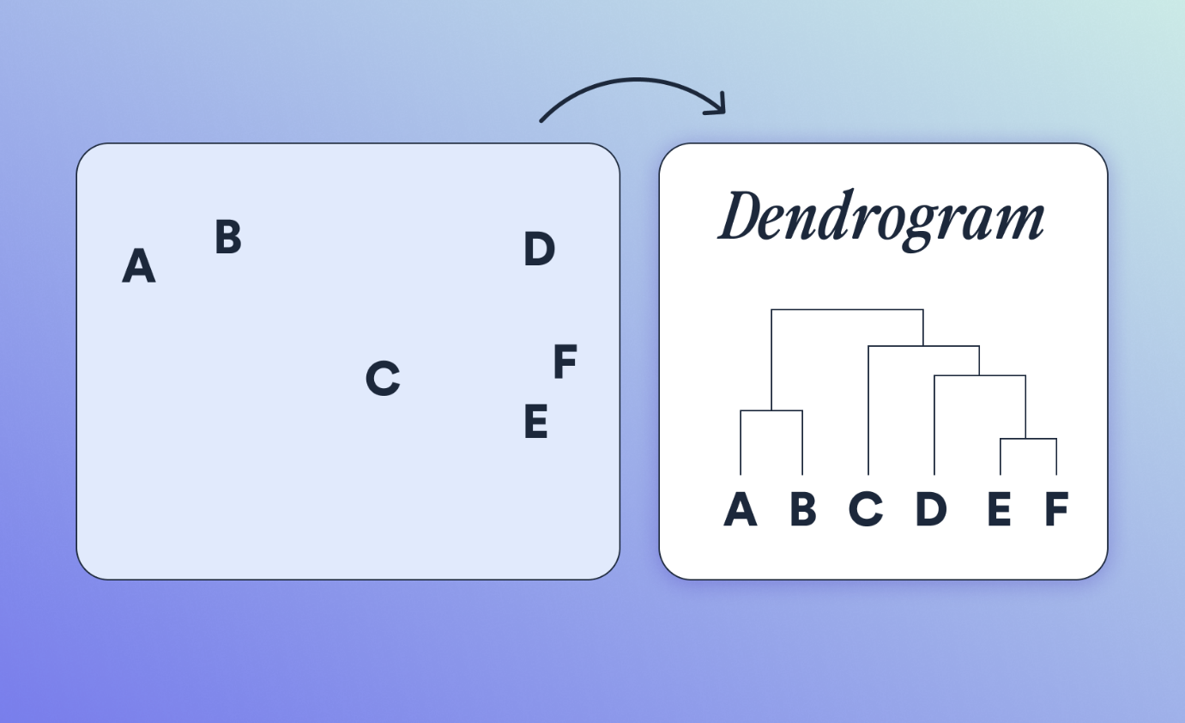

Both can be implemented using scikit-learn

Practical application of clustering

Customer insight (retail)
- A supermarket finds customers cluster into
  - Budget buyers
  - Premium buyers
Helps in store layout and promotions

Marketing
- Group audience by behavior to run different ads
- Ex – Netflix recommends shows differently to kids vs teens vs adults

Social media
- Twitter clusters users into groups with similar interests
Medial
- Clustering groups patients with similar DNA patterns
- Helps in drug discovery and disease risk prediction

Customer segmentation (online retail dataset)
- Assume as manager
- You would like to divide customers into groups so that you can design diff campaigns
  - Big spenders give loyality rewards
  - Occasional buyers send discounts to increase purchase frequency
  - One-time buyers send reactivation offers
Clustering = technique (bone by algorithm)
Segmentation = business strategy (deciding how to use those clusters)

Euclidean distance
Clustering works by grouping data points that are similar / close to each other
How close they are?
ED it’s the straight line distance between two points

Formula
Two points X and Y in n dimensions –

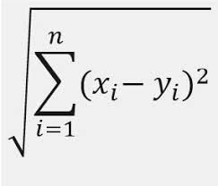

reference

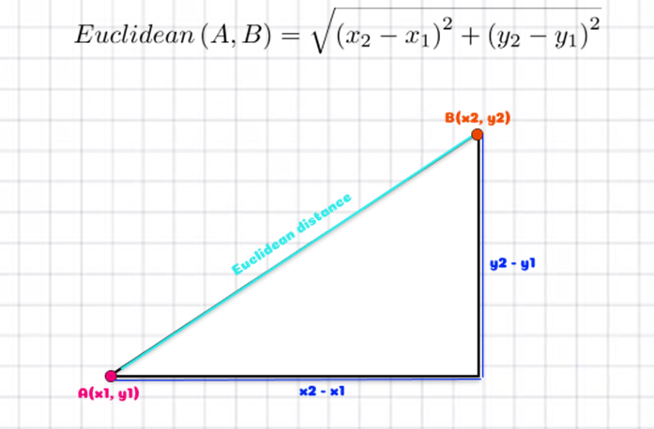

Ex
2 students
- Student A scored (Math =80, Science=85)
- Student B scored (Math = 70, Science=60)

ED = square root of (80 – 70)^2 + (85-60)^2 = square root of (100 + 625) ~ 26.9
These two students are 26.9 units apart in terms of their performance
If we had two students very close in score, their distance would be similar – meaning they are similar and may belong to same cluster

Key point
The smaller the distance, the more similar the data points

Centroid
It is center point of a cluster
Centroid = it represents average position of all points within that cluster

Ex
Lets say 4 sstudents in cluster with following height, weight ,age

Student | H | W | A
A 175 83 22
B 165 74 25
C 183 98 24
D 172 80 24

Find centroid ?
- Height mean = (175 + 165 + 183 + 172) / 4 = 173.75
- Weight mean = (83 + 74 + 98 +80)/4 = 83.75
- Age mean = (22 + 25 + 24+ 24) / 4 = 23.75
Centroid = (173.75, 83.75, 23.75)
This centroid represents the average student in that cluster
K – mean algorithm (steps)

Start with N data points and want to form K clusters
For x – 10 students, 2 groups

Step-1 choose K
Number of clusters , K=2

Step-2 initialize centroids
Randomly choosing K points from the data as initial centroids
Step-3 assignment
For each data point, calculate its distance to each centroid and assign it to the closest centroid
Step-4 update step
After assigning all points, recalculate the centroid of each cluster by taking the mean of all points in that cluster
Step-5 repeat
Repeat steps 3 and 4 until all centroids stop changing - converged

Mathematical form
k-means minimizes the sum of squared distances between data point and their respective cluster centroids

cost function for k-means algorithm
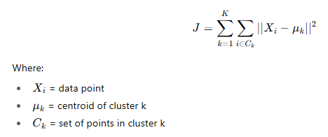

The algorithm alternates between
- Assignment step

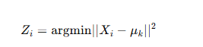

- Optimization step
Recalculate the centroid as the mean of assigned points

This continuous until the centroids no longer move

K-means++ algorithm
One issue with K-Means is it starts with random centroids, which can sometimes give poor results or diff clusters each time
To solve this – we use K- Means++, which smartly choose initial centroids

Steps
- Randomly choose the first centroid
- For every other data point, calculate its distance to the nearest chosen centroid
- Choose the next centroid with probability proportional to the square of the distance
- Repeat until K centroid are chosen

Ex
Imagine that clustering 100 students marks
Instead of picking any two random students as starting points, K-means ++ picks one, then ensures the next centroid is far away – ensuring better spread and faster convergence

Practical considerations
When applying K-means , there practical issues to consider
- Choosing K
Need to decide no.of cluster before hand
Use methods like Elbow method to choose K
- Initialization
Different initial centroids may lead to diff results (use K-Means++)

- Outliers
  - Clusters can distort centroids, so need to handle them before clustering
- Feature scaling
Since K-Means uses Euclidean distance, all features should be on same scale (use standardization)

- Data type
k-means works only for numerical data, not categorical data

- Convergence
Sometimes algorithm doesn’t converge within given iterations – always check

Ex
If clustering customers using “Age” and “Income”
Make sure to scale them – otherwise, “Income” will dominate since its values are much larger numerically

Cluster Tendency
Before applying K-means, its imp to check if the data actually has clusters –
This process is called Cluster Tendency
To check this – Hopkins Test
If Hopkins value is close to 1, data has meaningful clusters
If its near 0.5, data is random and not suitable for clustering

Silhouette analysis
Once clusters are formed, how you can decide they are good?
Use Silhouette coefficient, which measure how similar a point is to its own cluster vs other clusters
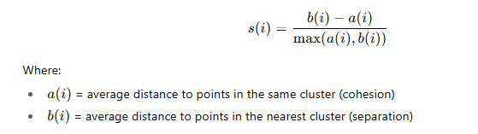

Ex
If a students silhouette score is 0.8, they are well matched to their own cluster
If its near 0, they lie between clusters
If negative, they may be in wrong cluster

